Professional Development Seminar: Team Building Activities and the Engineering Design Process
Speakers: Abbie Humbert and David Vernot
Date: Tuesday, June 14, 2016
Time: 1:00 – 4:00 PM
Venue: University of Cincinnati, Zimmer Hall, room 414

Prepared by:
Amy Parker, Finneytown High School, Cincinnati, Ohio
RET Participant for Project #1: “Application of Nanocomposites on Controlling Biofilms in Drinking Water Distribution System”

This session was given by David Vernot, a consultor with Butler County ESC, and Abbie Humbert, a sixth grade science teacher and member of CEEMS Cohort 4, on Tuesday, June 14, 2016 from 1:00 – 4:00 PM at the University of Cincinnati in Zimmer Hall, room 414. Although Vernot and Humbert differ greatly in terms of their years in the field of education, each presenter had something unique to bring to the workshop. Vernot spent the majority of his time, while in the field of education, serving as an educator in Fairfield City Schools. For roughly 30 years, he taught, wrote curriculum, and designed assessments, before retiring and beginning the role of consultor for various entities, including the Ohio Department of Education, the University of Cincinnati (CEEMS program), and Butler County ESC. Newer to the field of education, Humbert graduated from the University of Cincinnati roughly four years ago with a degree in Middle School Education, specifically mathematics and natural sciences. The objectives of this Professional Development Seminar were to describe the Engineering Design Process (EDP) and identify each of the steps, view examples of EDP in the classroom, and understand how EDP is used in the real-world.

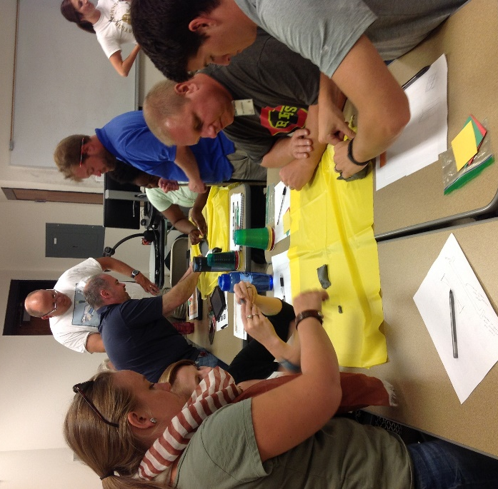

Figure 1: Building Prototypes in the Engineering Design Process.

The workshop began with a brief introduction from David Vernot on the Engineering Design Process (EDP). He briefly described that the EDP is a dynamic, multi-step process that is used to come up with a solution to a problem or challenge. The steps are as follows: Identify and Define the Problem, Gather Information, Identify Alternatives, Select Solution, Implement Solution, Evaluate Solution, Refine, and Communicate. These steps can be done in any order, and a strong emphasis is placed on the reiterative portion of the process, in which solutions are evaluated and redesigning takes place. Vernot then turned the stage over to Abbie Humbert, who directed the group through a unit that she created for her sixth grade science class that incorporated the EDP. The unit that she presented focused on the main concept of density and was entitled Surviving Density.
In the unit Surviving Density, Abbie Humbert guided the group to the challenge, “Come up with a way to survive a plane crash by building a flotation device to get as many passengers to safety as possible.” After dividing the group into smaller groups of four, she had the groups attempt the challenge, while walking them through the steps of the EDP. Each group needed to first define the constraints, such as materials, time, and space, then gather information to assist in the design of their flotation devices. Within each group, each individual designed their own solution, conveying it through the drawing of a very detailed sketch. After sharing, comparing, and critiquing each other’s sketches, each group selected their best solution to build as their first prototype. The first prototype was implemented, evaluated, and then redesigned to improve its effectiveness with completing the challenge. Redesigning continued to take place until either time ran out, or the group was unable to further improve on their design. Not every group was successful, but by walking through the challenge and using the EDP as students, a greater understanding was brought to the process.

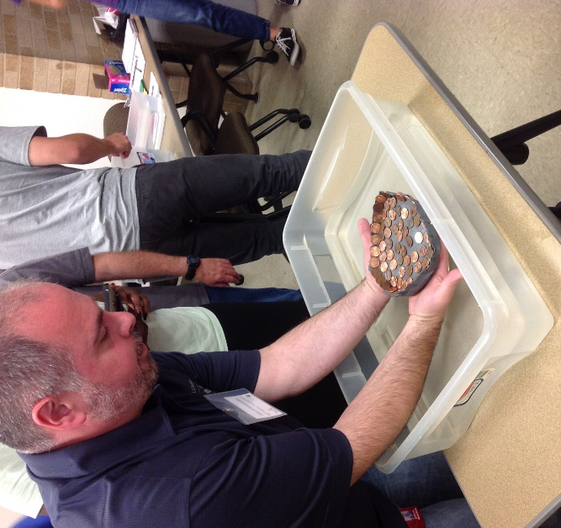

Figure 2: Testing a Prototype Flotation Device

Following the completion of Abbie Humbert’s teaching, David Vernot introduced a video relating to the careers that use the EDP on a day-to-day basis. In his video, Ted Verst, a director of structural engineering services, described the importance of the EDP in his work. Specifically, relating to his recent design of the Mercy Health Headquarters building, Verst described in detail the engineering behind the building and how each of the steps in the EDP apply to the creation of the building. Verst really emphasized the importance of redesign and communication in the EDP. Multiple times, while a building is in the middle of construction, the client changes a decision relating to the design of the building and then communicates this change to the engineers. The engineers must then make changes to the design, implement these changes, and evaluate their safety. The EDP is a dynamic cycle that has communication at its center.
Both presenters not only outlined and listed the steps of the Engineering Design Process, but they also provided solid examples of different lessons that could be used in the classroom that involve this process. David Vernot also provided numerous websites that could be used as valuable resources when striving to implement the Engineering Design Process in the classroom.

